Early Childhood & School–Age Program Consultation Checklist

Indicators and Resources to Guide the Consultation Process.

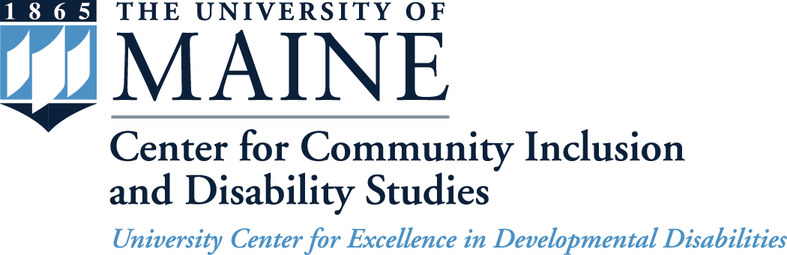

Consultation Checklist

The Checklist offers guidance in providing process consultation using an established planning/ problem-solving framework.

1. Planning the consultation.
2. Gathering Information to define the issue / focus.
- Gaining Entry & Building a Relationship.
- Assessment.
3. Reviewing Assessment Information to identify a shared understanding of the issue / focus.
4. Developing the TA Plan to generate ideas and solutions to address the issue/ focus.
5. Implementing the TA Plan by selecting and trying out the strategies that best address the issue.
6. Evaluating the TA Plan.
7. Holding the Summary Conference.

The Checklist can be used by individual consultant’s to plan for consultation activities, guide the delivery of consultation or as a tool for self-reflection and review following consultation visits.

It can also provide guidance to supervisors and directors in agencies offering consultation/ technical assistance to support the orientation of professionals entering the field and/ or as a structure for reflective supervision for new and veteran consultants.

Indicators  Planning the Consultation  Goal |  | Reflective Questions | Notes
- Review consultation request and any additional, related information.  - Review any information about past experiences with the program.  - Call the program to discuss contact options/ arrange visit.  - Select any forms and paperwork needed for the consultation.  - Gather information that is relevant to the consultee’s situation including their involvement with the Quality Rating System, Accreditation, Licensing, involvement with other TA Network consultants, etc.  - Select materials /resource books that you plan to take/share. |  | - Have I had previous consultation with this program/provider?  - If so, what did I learn and how can it inform this process?  - If I know or have worked with this program/ staff, what might I need to consider to maintain objectivity?  - When arranging for the program visit, what initial information did I provide to ensure that the program knows who should be present, how long the visit will last, and what will happen?  - Do I know how to get to the program location? If not, have I used Mapquest.com or other navigation tool to identify the best route? | 1. How will I communicate to my contact at the program about my expectations for the first onsite visit, what specifically will I say?
Indicators  Gathering Information | Reflective Questions |  |  | Notes
- Meet with the Director & staff to provide information about consultation & program roles/ responsibilities & how you will work together with staff.  - Discuss general purpose & process of consultation.  - Review program documents or materials (program policies, handbooks, etc).  - Discuss any previously completed assessments.  - Visit/ observe the classroom/ program.  - Complete a program assessment if needed.  - Talk about how you will share any completed assessment information. | - What specific strategies did I use to learn about the program and consultee?  - How did my communication (attending & active listening, seeking & verifying information) promote relationship building?  - How well do I think the consultee understands the purpose and process of consultation?  - What have I learned about the focus of concern?  - Do I have enough information to develop recommendations? If not what other information do I need and how will I get this?  - What did I select that provided “standardized” or evidence based practice guidance when doing the program assessment?  - What ideas or information did the consultee contribute during the information gathering? |  |  | - How will I include all sources of information including previous assessment results, input from program staff & families, and observation of the environment as you move forward with determining the focus of the consultation?

Indicators  Reviewing Assessment Information | Reflective Questions | Notes
- Jointly review gathered information & assessment results.  - Discuss the consultee’s concerns or issues and priorities based on the results.  - Discuss your initial recommendations for addressing the needs.  - Determine TA Level 3 or 4. (proceed if Level 4)  - Determine the need for involvement of other consultants from the TA network.  - Have the consultee sign a consultant release if indicated.  - Determine a plan for the next contact. | - Have I completed / gathered all assessment information to inform the development of the TA plan?  - Do I need to return to do more assessments?  - What specific strategies did I use to share information and results?  - What did I do to ensure collaboration in identifying the focus / issue?  - Do we (consultant & consultee) have a common understanding of the issue/ focus or problem?  - Should anyone else get this information (other consultants, licensing, etc)? If so, how, when and by whom?  - How will the director /leadership be involved? | 1. What will I do to ensure collaboration in (1) identifying all areas of concern from everyone involved, and (2) determining the focus of the consultation?
Developing the TA Plan
Indicators | Reflective Questions | Notes
- Brainstorm specific activities to address priority areas.  - Identify with the consultee the activity (activities) that best match the issue/ focus.  - If they are on the QRS, use this guidance in developing the plan.  - Develop the plan to specifically outline the responsibilities (who needs to do what) of the consultant & the consultee.  - If the program is working with others in the TA Network on quality improvement activities, accreditation plans or the inclusion or a child(ren) with special needs, discuss how to connect these efforts.  - Identify how both consultee and consultant will know when the activities have been accomplished (measurable outcomes).  - Sign and distribute copies of the TA plan to appropriate individuals including Director/Leadership. | - Does the plan spell out in concrete and specific language what needs to be done, how, by whom and when?  - Do the activities relate to the assessment data gathered?  - How reasonable is the TA plan in terms of number of activities/timeframe and responsibilities?  - What strategies did I use to ensure that there was mutual involvement of the consultant and the consultee in developing the TA plan?  - Does the consultee “own” the selected activities? | 1. How will I ensure that the plan spells out in concrete and specific language what needs to be done, how, by whom and when in a reasonable fashion?

Indicators  Implementing the TA Plan | Reflective Questions | Notes
- Provide ongoing consultation to support the consultee as specified in the plan. These may include:  - Observation  - Modeling  - Meetings with teachers/ administrators/families  - Meetings with groups or teams of staff  - Professional development  - Determine how TA will be provided (on-site, phone, email, etc).  - Provide ongoing assessment of the plan to evaluate the effectiveness and make modifications as needed. | - How is the plan going?  - How difficult is it for the consultee to implement the plan when the consultant is not present?  - How effective are the check-ins/support from consultant?  - What particular communication, coaching or feedback strategies am I using during consultation?  - How well am I able to provide constructive, specific and supportive feedback to assist the staff toward using or strengthening recommended practices.  - How is the director/leadership involved?  - What resources and/or strategies am I providing to build capacity? | 1. How will I provide constructive, specific and supportive feedback to assist the staff toward using or strengthening recommended practices?

Indicators  Evaluating the TA Plan | Reflective Questions | Notes
- Review the TA plan to determine which recommendations / activities were met.  - Determine which recommendations / activities were not met and why?  - Discuss with the consultee the purpose of summary conference & provide suggestions for their preparation and participation.  - Schedule a summary conference meeting with the program staff. | - Did the TA plan address the focus issue/ problem?  - Was the plan realistic?  - What was learned about the consultation process?  - Were there any unexpected or unanticipated outcomes?  - How was the director/leadership involved in the evaluation?  - Did the consultee view this as a partnership with the consultant working with and not for the consultee? | 1. How will I know if the plan addressed the focus issue/problem?

Indicators  Holding a Summary Conference | Reflective Questions | Notes
- Meet in a mutually agreed upon setting with the program staff to discuss the evaluation of the consultation.  - Jointly review the consultation process and the TA plan.  - Determine next steps.  - If closing the TA, provide information about the TA evaluation process – what, who and how this will be done.  - Complete exit information. | - What will the consultee say about the changes as a result of the consultation? (program changes, teaching strategies, child outcomes?)  - Did the activities and the consultation strategies increase the ability of the consultant to deal with a similar situation or problem?  - What information did the consultee share to assist you to do this work even better next time?  - What information was used to determine whether to close, refer or continue to provide consultation?  - What was the formal process for closure of the current TA plan/consultation session? | 1. How will I know if the activities and the consultation strategies increased the ability of the consultee to deal with a similar situation of problem?  2. What information will I gather from the consultee to assist me to do this work even better next time?

Resources used to develop this checklist:

Buysee & Wesley, (2005). Consultation in early childhood settings. Baltimore: Brookes.

Dettmer, P., Dyck, N., & Thurston, L. P. (1993). Chapter 5: Problem-solving strategies for consultation, collaboration and teamwork. In R. Short (ed.), Consultation, collaboration, and teamwork for students with special needs. 309 (345). Boston: Allyn and Bacon.

Perry-Manning, S., Foulks, D., Houston, B. (2005). Opening the door to quality: A guide to providing effective, on-site, technical assistance in center-based child care programs. Washington, D.C.: NACCRRA.

Perry-Manning, S., Foulks, D. (2005). Opening the door to quality: A guide to providing effective, on-site, technical assistance in family child care homes. Washington, D.C.: NACCRRA

