**SAM (Stylized Adaptive Mobility) Device the Project**

**Stephen Gilson, PhD**

**Elizabeth DePoy, PhD**

**Vince Caccese, PhD**

**What is SAM?**

SAM is a state-of-the art, aesthetically designed fitness support to enable ambulatory persons who need or want balance, stability, and/or weight bearing assistance to participate in outdoor jogging, running, and distance walking activity in diverse terrain.

SAM is lightweight, actively steered, has a breaking system for full control, is foldable and convenient to transport, and fitted with an innovative wireless sensing and feedback system to track and communicate activity level, energy usage, and vital signs to user and, if appropriate, to health provider.

**Why was SAM developed?**

* No devices exist for the large number of ambulatory persons who would otherwise be able to engage in fitness with the assistance of readily available, standing-supportive equipment designed specifically for exercise.
* The available ambulation support devices remain the domain of durable medical equipment, which is not designed, engineered, and fabricated to support safe fitness activity.
* People do not like the stigmatizing design of currently available durable medical equipment, leading to abandonment and promoting sedentary lifestyles that result in further decline in health and fitness.

**For Whom was SAM Developed?**

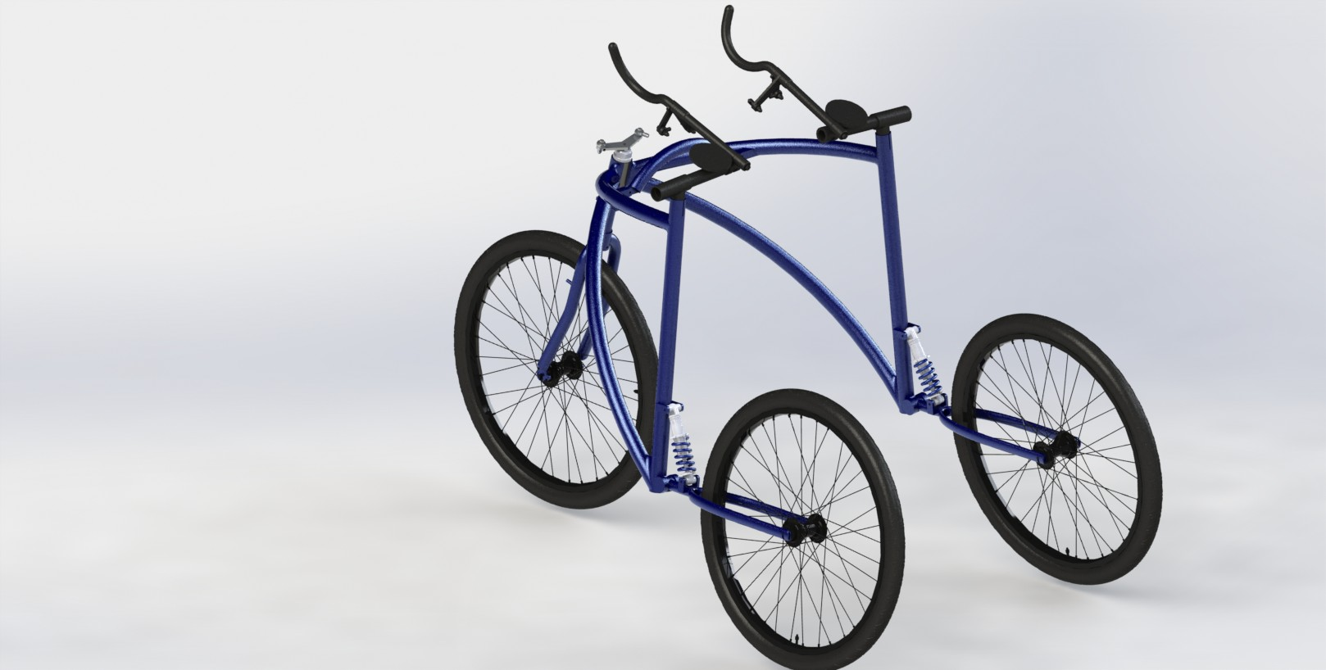All people including but not limited to those with arthritis, limited strength and/or balance, joint replacement, obese and overweight individuals, individuals with osteopenia and osteoporosis.

