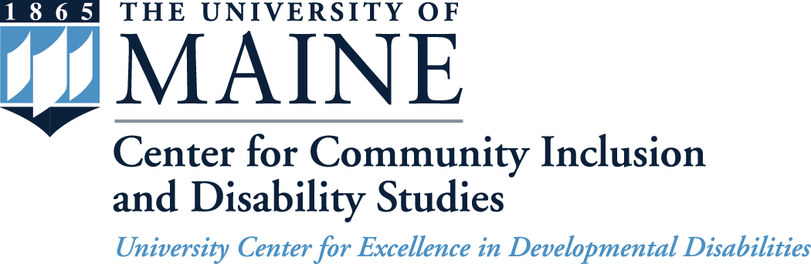
5717 Corbett Hall, Room 227
Orono, ME 04469-5717
207.581.1084 (v)
800.203.6957 (toll-free v)
TTY users: Maine Relay 711
ccids.umaine.edu
ccidsmail@maine.edu

Community Advisory Committee Meeting
University of Maine at Augusta
Holocaust and Human Rights Center of Maine
Michael Klahr Center Conference Room
46 University Drive, Augusta, ME 04330

Thursday - October 29, 2015

AGENDA

9:30 a.m. to 10:00 a.m. Arrival, Light Refreshments and Networking

10:00 a.m. to 10:30 a.m. Welcome, Introductions and Icebreaker
- Welcome Kathy Adams and Cindy Brown!

10:30 a.m. to 11:15 a.m. Review of the Day and Director’s Update

11:15 a.m. to 11:45 a.m. Old Business
- Keeping Members Connected
- Process for Annual Review and Comment on
Year 3 Progress of CCIDS Five-Year Plan
New Business
- Membership Update
- Ad hoc Nominating Committee

11:45 a.m. to 12:00 p.m. Prepare for Afternoon Breakout Sessions on
Year 3 (2015-2016) Goals and Objectives

12:00 p.m. to 12:30 p.m. LUNCH (provided)

12:30 p.m. to 1:15 p.m. Breakout Sessions on Year 3 Goals and Objectives (30-minute discussion and 15 minutes to prepare report)

1:15 p.m. to 1:45 p.m. Breakout Reports

1:45 p.m. to 2:00 p.m. Wrap-up, Meeting Feedback and Trick or Treat!

