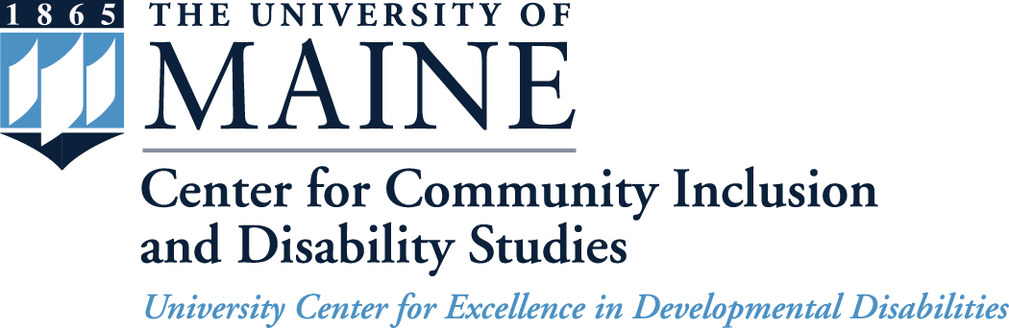
5717 Corbett Hall, Room 234
Orono, ME 04469-5717
207.581.1084 (v)
800.203.6957 (toll-free v)
TTY users: Maine Relay 711
ccids.umaine.edu
ccidsmail@maine.edu

Community Advisory Committee Meeting
University of Maine
Wells Conference Center, Room 3
Wednesday - June 29, 2016

AGENDA

9:30 a.m. to 10:00 a.m. Arrival, Light Refreshments and Networking

10:00 a.m. to 10:05 a.m. Welcome

10:05 a.m. to 10:10 a.m. Review of the Day

10:10 a.m. to 10:20 a.m. Director’s Update

10:20 a.m. to 10:30 a.m. Old Business
- Membership Update
10:30 a.m. to 11:30 a.m. Research Summary

11:30 a.m. to 12:00 p.m. Goals & Objectives
- Questions about Progress Report
- Objectives for Coming Year
12:00 p.m. to 12:30 p.m. LUNCH (provided)

12:30 p.m. to 1:00 p.m. Potential Research and TA Activity

1:00 p.m. to 1:45 p.m. Waiver & Person Centered Planning

1:45 p.m. to 2:00 p.m. Wrap-up and Meeting Feedback

